Senzo Zwelihle Masango

SKS412 Summative

4471

zwelihle

Table of contents

Use case Exercises

Question 1

Question 2

Top level uses cases

view items use case

Online shopping diagram

Question 3

Question 2

Question 3

Class diagrams

Question 1

Question 2

Question 3

Question 4

Sequence diagrams

Question 1

Question 2

Use case Exercises

Question 1

General manager

Store Manager

Customer

Laser-Printer

Store Database

Barcode Reader

Clothing Store System

Print bill

Update items

Update store, create accounts, request reports

Send scanned barcode item barcode

Hang, print, cancel bill, request reports

Deliver bill and the rest

By items, pay bill, return items

Question 2

Top level uses cases

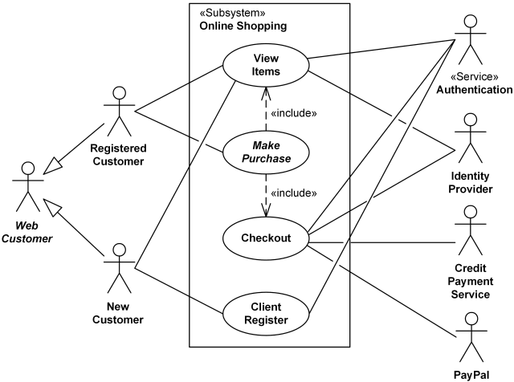

view items use case

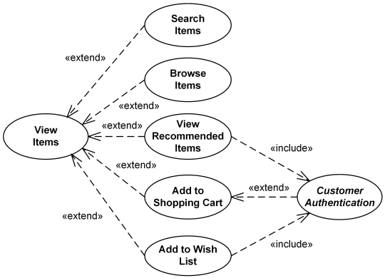

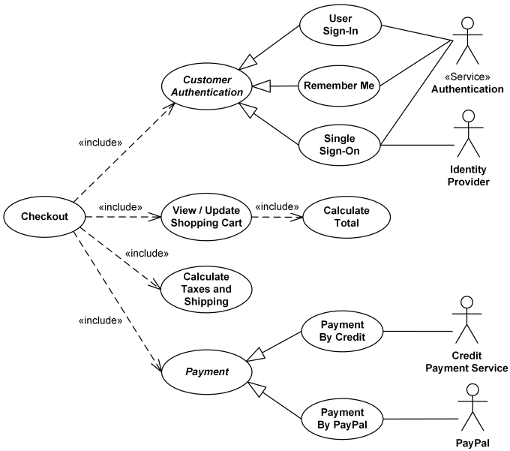Online shopping diagram

Question 3

Question 2

Locate and go to the book store

Check availability of books

customer

Book Seller

Pay for the book

Search another store

If available

yes

No

State book availability to customer

Ask for desired book

[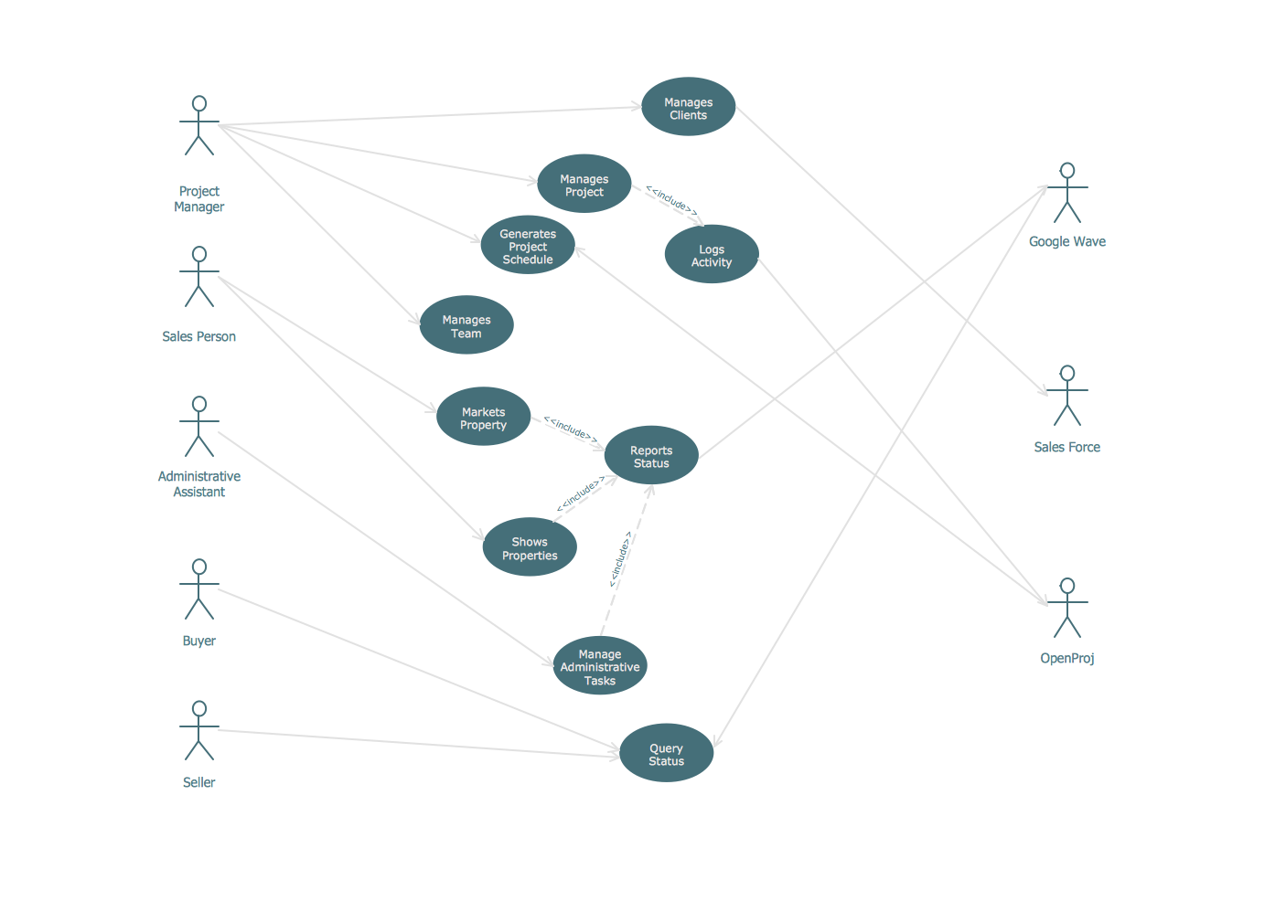](https://www.conceptdraw.com/How-To-Guide/picture/UML-diagram-estate-agency.png)Question 3

Class diagrams

Question 1

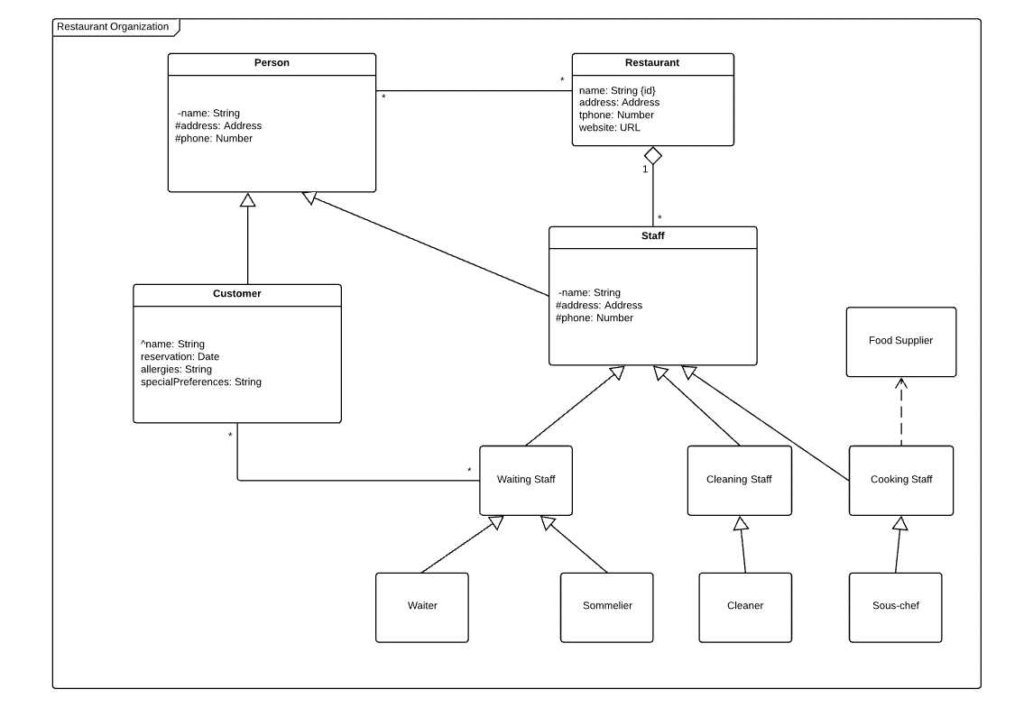

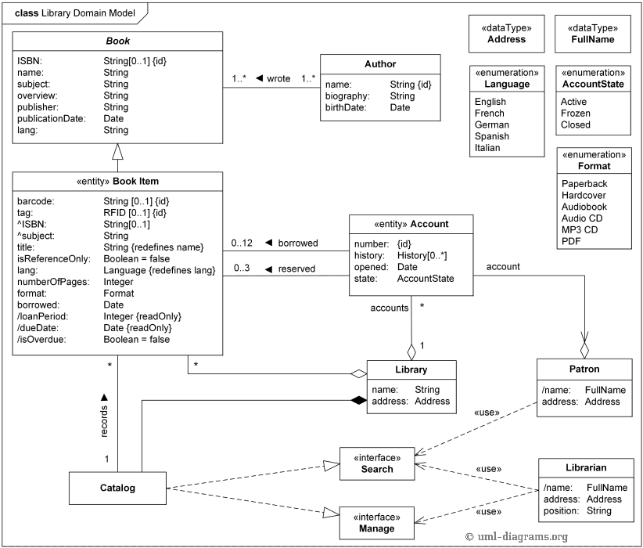Question 2

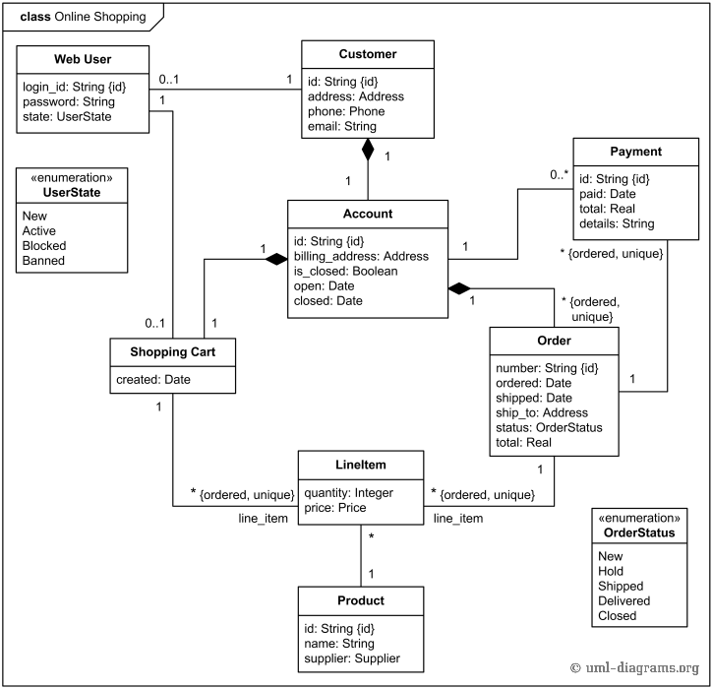Question 3

Question 4



Sequence diagrams

Question 1

**Person**

FirstName: String

MiddleName: String

LastName: String

**DeliveryAgent**

deliveryZone: String

Schedule: String

**Order**

Id: Integer

Schedule: String

ChangeStatus

**itemPerLine**

quantity: Integer

pricePerUnit: Float

**DVD**

Title: String

Duration: Iteger

Category: String

checkEnoughInventory:boolean

**ShoppingCart**

subtotal: Float

taxes: Float

total: Float

shippingAddress: String

**Customer**

billingAddress: String

ShippingAddress: String

Status: Integer

changeStatus(): void

**Admin**

ExtensionNumber: Integer

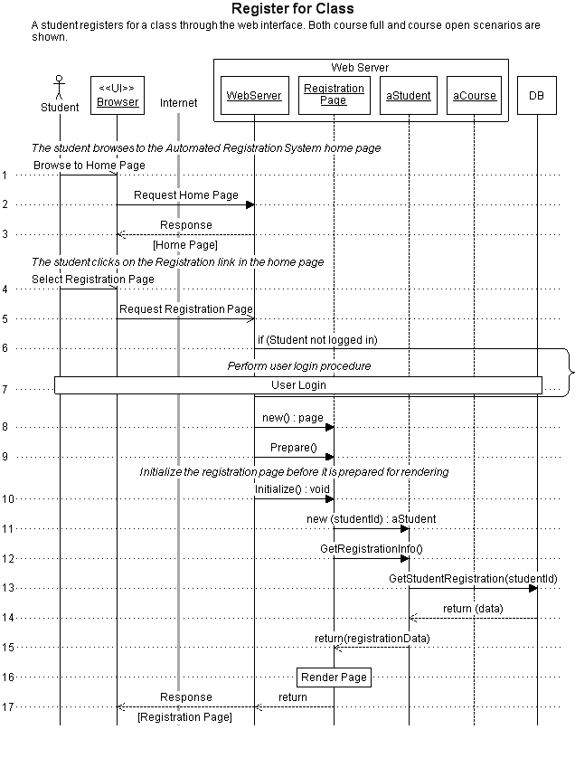Question 2